**17. Kubernetes Deployment - Rollback Application to Previous Version – Undo**

--- **Reference** - https://github.com/stacksimplify/kubernetes-fundamentals/tree/master/04-Deployments-with-kubectl/04-03-Rollback-Deployment

--- **note** – in this lesion, we will learn about roll back deployment.

**Introduction**

--- We can rollback a deployment in two ways.

1. Previous Version
2. Specific Version

**Rollback a Deployment to previous version**

--- Check the Rollout History of a Deployment

**# List Deployment Rollout History**

--- **kubectl rollout history deployment/<Deployment-Name>**

--- **kubectl rollout history deployment/my-first-deployment**

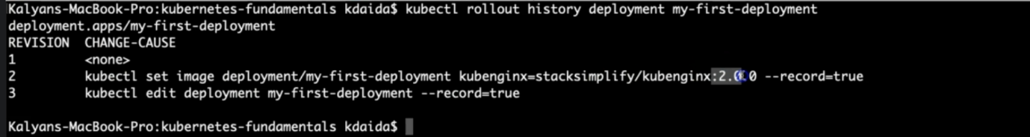

--- **note** – we have done total 3 deployments.

**Verify changes in each revision**

--- **Observation**: Review the "Annotations" and "Image" tags for clear understanding about changes.

**# List Deployment History with revision information**

--- **kubectl rollout history deployment/my-first-deployment --revision=1** – you want to see, what happened in the deployment1. Review the "Annotations" and "Image" tags for clear understanding about changes.

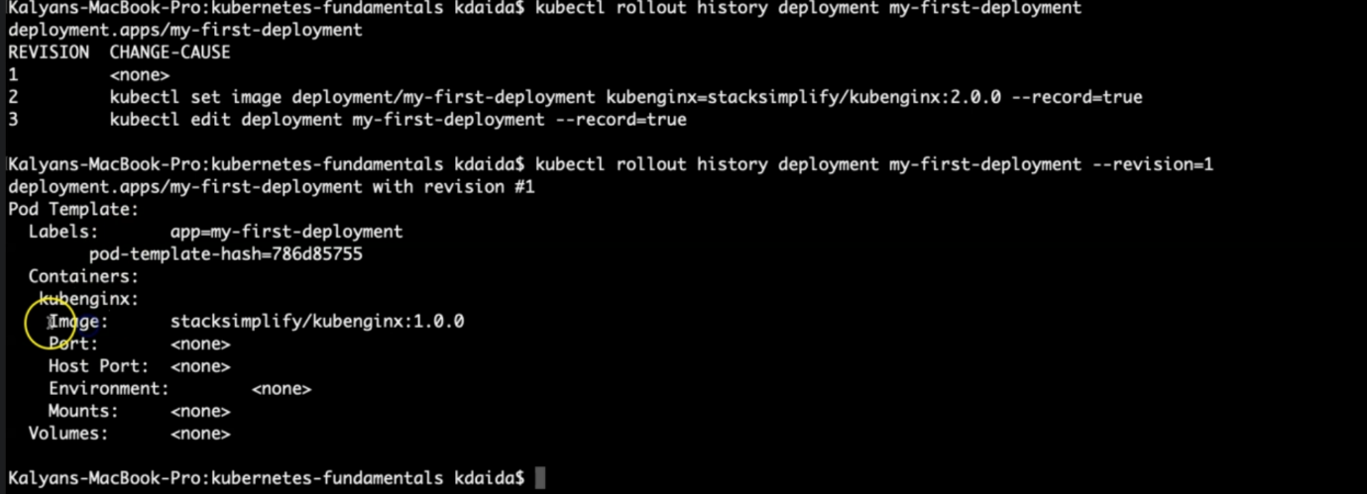

--- **kubectl rollout history deployment/my-first-deployment --revision=2** – you want to see, what happened in the 2nd deployment.

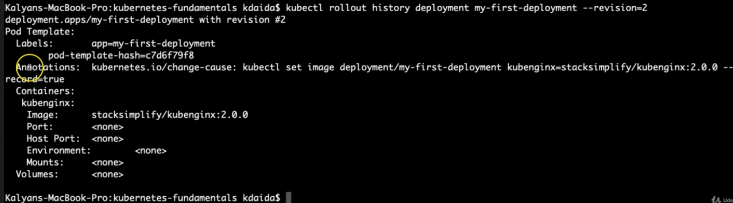

--- **note** – observe the change-cause in the annotations.

--- **kubectl rollout history deployment/my-first-deployment --revision=3**

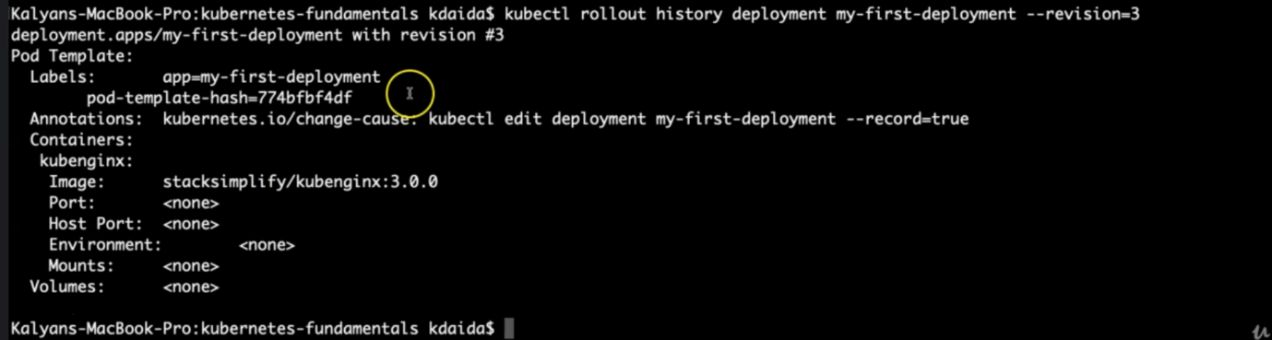

--- here also, you can observe the change cause in the annotations.

**Rollback to previous version**

--- **Observation**: If we rollback, it will go back to revision-2 and its number increases to revision-4

**# Undo Deployment**

--- **kubectl rollout undo deployment/my-first-deployment**

**# List Deployment Rollout History**

--- **kubectl rollout history deployment/my-first-deployment**

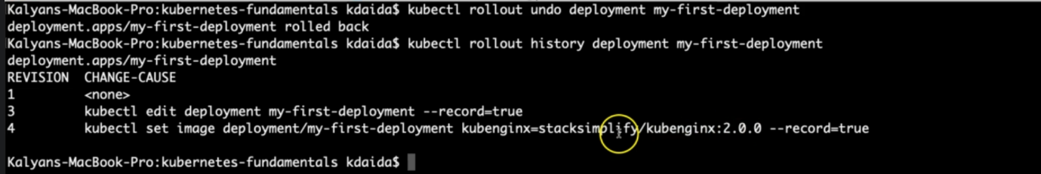

--- **note** - from revision 3, you went back to revision 2. That is why revision2 is not there. Because of the revert back, you can able to see revision 4.

**Verify Deployment, Pods, ReplicaSets**

--- **kubectl get deploy**

--- **kubectl get rs**

--- **kubectl get po**

--- **kubectl describe deploy my-first-deployment**

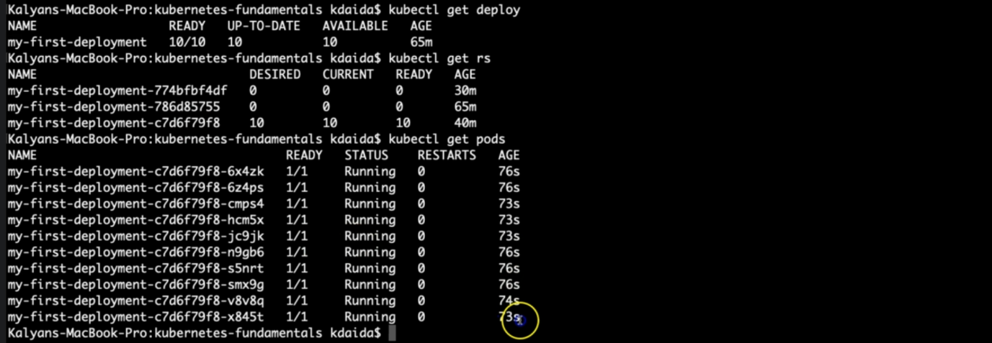

--- note – pod label refers to the 2nd rs label.

**Access the Application using Public IP**

--- **note** - We should see Application Version:V2 whenever we access the application in browser

**# Get NodePort**

--- **kubectl get svc**

--- **Observation:** Make a note of port which starts with 3 (Example: 80:3xxxx/TCP). Capture the port 3xxxx and use it in application URL below.

**# Get Public IP of Worker Nodes**

--- **kubectl get nodes -o wide**

--- **Observation**: Make a note of "EXTERNAL-IP" if your Kubernetes cluster is setup on AWS EKS.

**# Application URL**

--- **http://<worker-node-public-ip>:<Node-Port>**

**Rollback to specific revision**

--- **note** - Check the Rollout History of a Deployment

**# List Deployment Rollout History**

--- **kubectl rollout history deployment/<Deployment-Name>**

--- **kubectl rollout history deployment/my-first-deployment**

**Rollback to specific revision**

**# Rollback Deployment to Specific Revision**

--- **kubectl rollout undo deployment/my-first-deployment --to-revision=3**

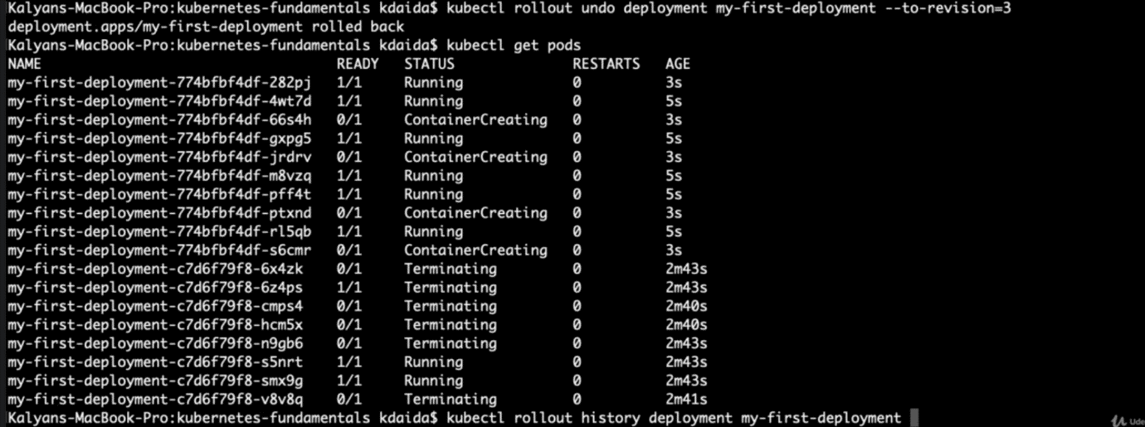

--- **note** – it is deleting and recreating the pods.

**List Deployment History**

--- **Observation**: If we rollback to revision 3, it will go back to revision-3 and its number increases to revision-5 in rollout history

**# List Deployment Rollout History**

--- **kubectl rollout history deployment/my-first-deployment**

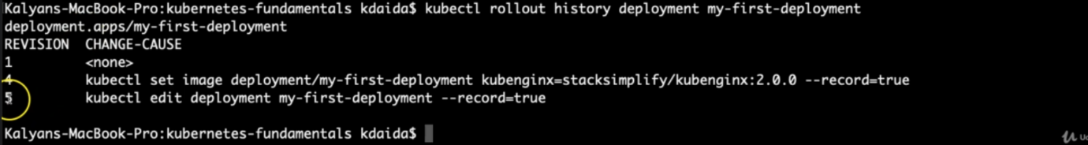

**Access the Application using Public IP**

--- **note** - We should see Application Version:V3 whenever we access the application in browser

**# Get NodePort**

--- **kubectl get svc**

--- **Observation:** Make a note of port which starts with 3 (Example: 80:3xxxx/TCP). Capture the port 3xxxx and use it in application URL below.

**# Get Public IP of Worker Nodes**

--- **kubectl get nodes -o wide**

--- **Observation**: Make a note of "EXTERNAL-IP" if your Kubernetes cluster is setup on AWS EKS.

**# Application URL**

--- **http://<worker-node-public-ip>:<Node-Port>**

**Rolling Restarts of Application**

--- note – you want to restart all of your application in rolling fashion because some memory issue or some other issue. You can use below commands.

--- **note** - Rolling restarts will kill the existing pods and recreate new pods in a rolling fashion.

**# Rolling Restarts**

--- **kubectl rollout restart deployment/<Deployment-Name>**

--- **kubectl rollout restart deployment/my-first-deployment**

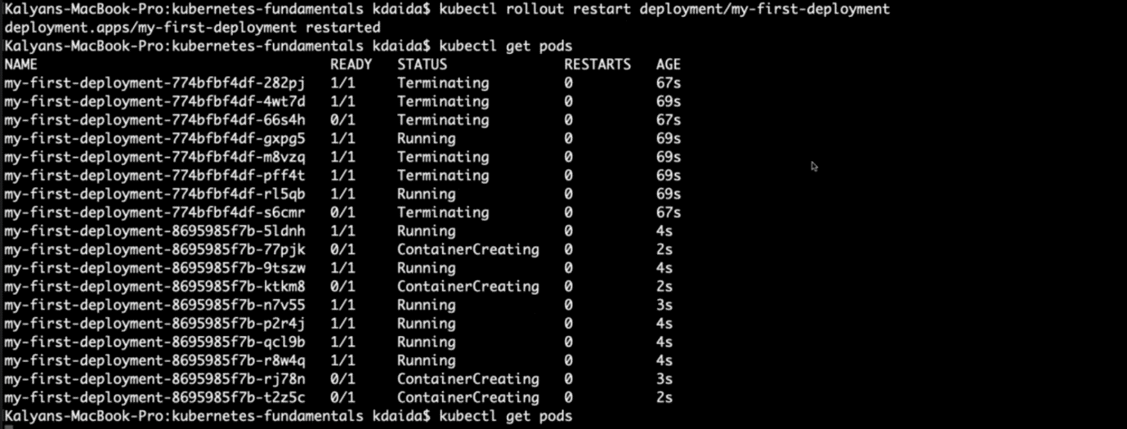

--- note - you can see that it is terminating and creating the pods.

**# Get list of Pods**

--- **kubectl get po**